**Practical-1**

**Aim: WAP to create a class Employee with setter and getter. Which have fields like id, name, role, salary, experience, address, email and contact. Get 5 records.**

**Program:**

#include<iostream>

#include<string.h>

using namespace std;

class Employee

{

private:

int emp_id;

char emp_name[100];

char emp_role[100];

int emp_salary;

int emp_experience;

char emp_address[100];

char emp_email[100];

char emp_contact[100];

public:

void setData()

{

cout << endl << "* Enter employee Details " << endl << endl;

cout << "=> Enter your id :- "; cin >> this->emp_id;

cout << "=> Enter your name :- "; cin >> this->emp_name;

cout << "=> Enter your role :- "; cin >> this->emp_role;

cout << "=> Enter your salary :- "; cin >> this->emp_salary;

cout << "=> Enter your experience :- "; cin >> this->emp_experience;

cout << "=> Enter your address :- "; cin >> this->emp_address;

cout << "=> Enter your email :- "; cin >> this->emp_email;

cout << "=> Enter your contact :- "; cin >> this->emp_contact;

cout << endl << "----------------------------------------------" << endl;

}

void getData()

{

cout << "* Employee Details" << endl << endl;

cout << "=> id : " << this->emp_id << endl

<< "=> name : " << this->emp_name << endl

<< "=> role : " << this->emp_role << endl

<< "=> salary : " << this->emp_salary << endl

<< "=> experience : " << this->emp_experience << endl

<< "=> address : " << this->emp_address << endl

<< "=> email : " << this->emp_email << endl

<< "=> contact : " << this->emp_contact << endl;

cout << endl << "----------------------------------------------" << endl << endl;

}

};

int main()

{

Employee e[5];

int i,n;

cout << "How many employee :- "; cin >> n;

for(i=0;i<n;i++)

{

e[i].setData();

}

for(i=0;i<n;i++)

{

e[i].getData();

}

return 0;

}

**Output:**

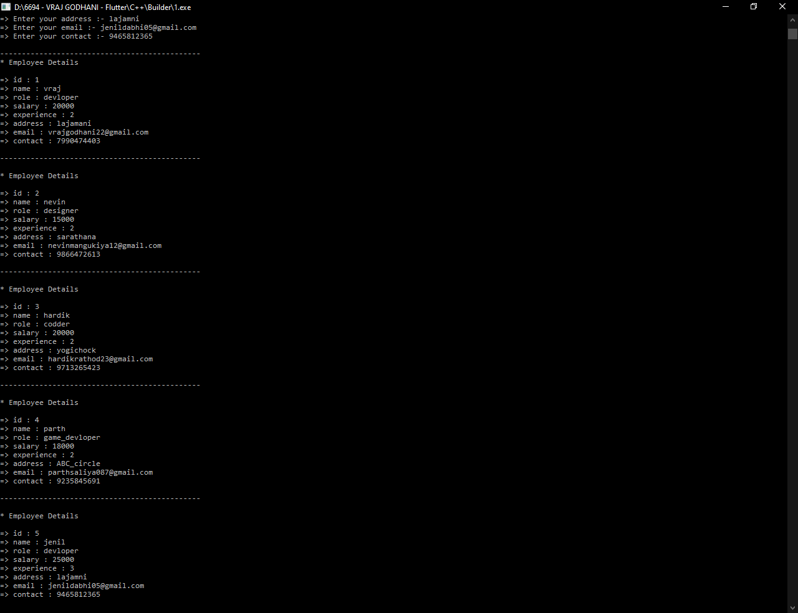

**Practical-2**

**Aim: WAP to create a class which Read and print Class, Student details using Two Classes. (Make two classes, create one classe's obj in another class.)**

**Program:**

#include<iostream>

#include<string.h>

using namespace std;

class Student

{

private:

char studentname[100];

int rollno;

int standard;

char schoolname[100];

public:

void setData()

{

cout << "* Enter student details :- " << endl << endl;

cout << "=> Enter your name :- "; cin >> this->studentname;

cout << "=> Enter your roll number :- "; cin >> this->rollno;

cout << "=> Enter your standard :- "; cin >> this-> standard;

cout << "=> Enter your school name :- "; cin >> this->schoolname;

cout<<endl<<"----------------------------------------------"<< endl << endl;

}

void getData()

{

cout << endl << endl << "* Student details :- " << endl << endl;

cout << "=> Your name :- " << this->studentname << endl;

cout << "=> Your roll number :- " << this->rollno << endl;

cout << "=> Your standard :- " << this-> standard << endl;

cout << "=> Your school name :- " << this->schoolname << endl;

cout << endl << "----------------------------------------------" << endl << endl;

}

};

class Classroom

{

Student s;

private:

int classroom;

int bench;

int student;

char sirname[100];

public:

void setData()

{

cout << "* Enter classroom detail :- " << endl << endl;

cout << "=> How many classroom in your school :- ";

cin >> this->classroom;

cout << "=> How many bench in your classroom :- ";

cin >> this->bench;

cout << "=> How many student in your classroom :- ";

cin >> this-> student;

cout << "=> What is your sir name :- ";

cin >> this->sirname;

cout << endl << "----------------------------------------------" << endl << endl;

s.setData();

}

void getData()

{

cout << "* Class details :- " << endl;

cout << endl << "=> Total classroom in your school :- "

<< this->classroom;

cout << endl << "=> Total bench in your classroom :- "

<< this->bench;

cout << endl << "=> Total student in your classroom :- "

<< this-> student;

cout << endl << "=> Your sir name :- " << this->sirname <<endl;

cout << endl << "----------------------------------------------";

s.getData();

}

};

int main()

{

Classroom c;

c.setData();

c.getData();

return 0;

}

**Output:**

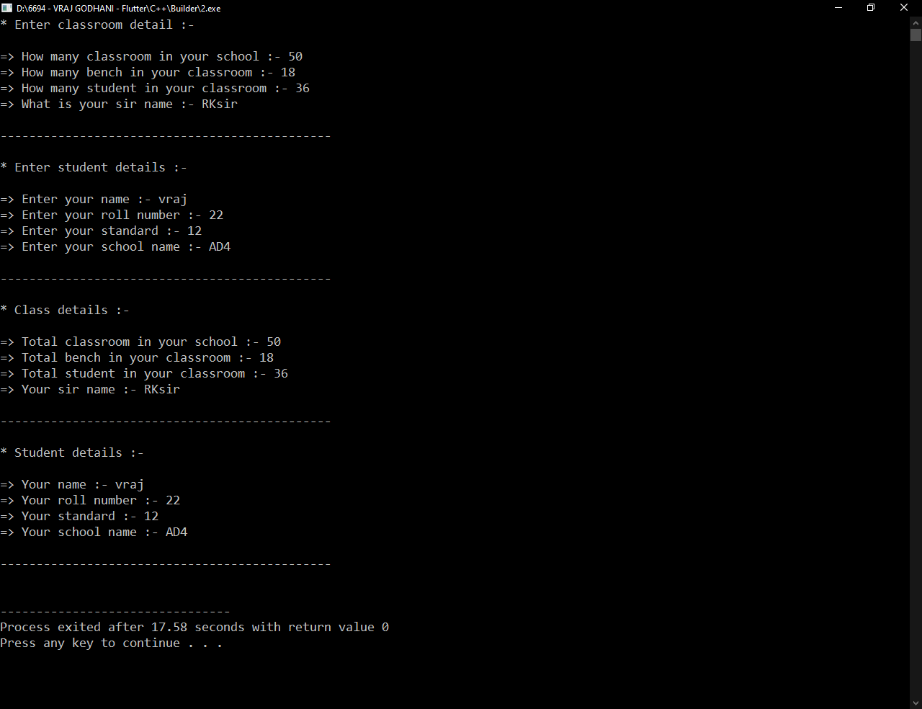

**Practical-3**

**Aim: WAP to create a class Hotel with fields like id, name, type, staff_size, room_size, establish_year, address, rating_type and website. Illustrate the use of encapsulation (strict encapsulation) with this keyword.**

**Program:**

#include<iostream>

#include<string.h>

using namespace std;

class Hotel

{

private:

int id;

char name[100];

char type[100];

int staff_size;

int room_size;

int establish_year;

char address[100];

int rating_type;

char website[100];

public:

void setData()

{

cout << "* Enter Hotel details :- " << endl << endl;

cout << "=> Enter hotel id :- ";

cin >> this->id;

cout << "=> Enter hotel name :- ";

cin >> this->name;

cout << "=> Enter hotel type :- ";

cin >> this-> type;

cout << "=> Enter hotel staff size :- ";

cin >> this->staff_size;

cout << "=> Enter hotel room size :- ";

cin >> this->room_size;

cout << "=> Enter hotel establish year :- ";

cin >> this->establish_year;

cout << "=> Enter hotel address :- ";

cin >> this->address;

cout << "=> Enter hotel rating type :- ";

cin >> this->rating_type;

cout << "=> Enter hotel website :- ";

cin >> this->website;

cout<<endl<<"----------------------------------------------"<< endl << endl;

}

void getData()

{

cout << endl << endl << "* Hotel details :- " << endl << endl;

cout << "=> Hotel id :- " << this->id << endl;

cout << "=> Hotel name :- " << this->name << endl;

cout << "=> Hotel type :- " << this-> type << endl;

cout << "=> Hotel staff size :- " << this->staff_size << endl;

cout << "=> Hotel room size :- " << this->room_size << endl;

cout << "=> Hotel establish year :- " << this->establish_year << endl;

cout << "=> Hotel address :- " << this->address << endl;

cout << "=> Hotel rating type :- " << this->rating_type << endl;

cout << "=> Hotel website :- " << this->website << endl;

cout<<endl<<"----------------------------------------------"<< endl << endl;

}

};

int main()

{

Hotel h[100];

int i,n;

cout << "=> How many hotel survey :- "; cin >> n;

cout << endl;

for(i=0;i<n;i++)

{

h[i].setData();

}

for(i=0;i<n;i++)

{

h[i].getData();

}

return 0;

}

**Output:**

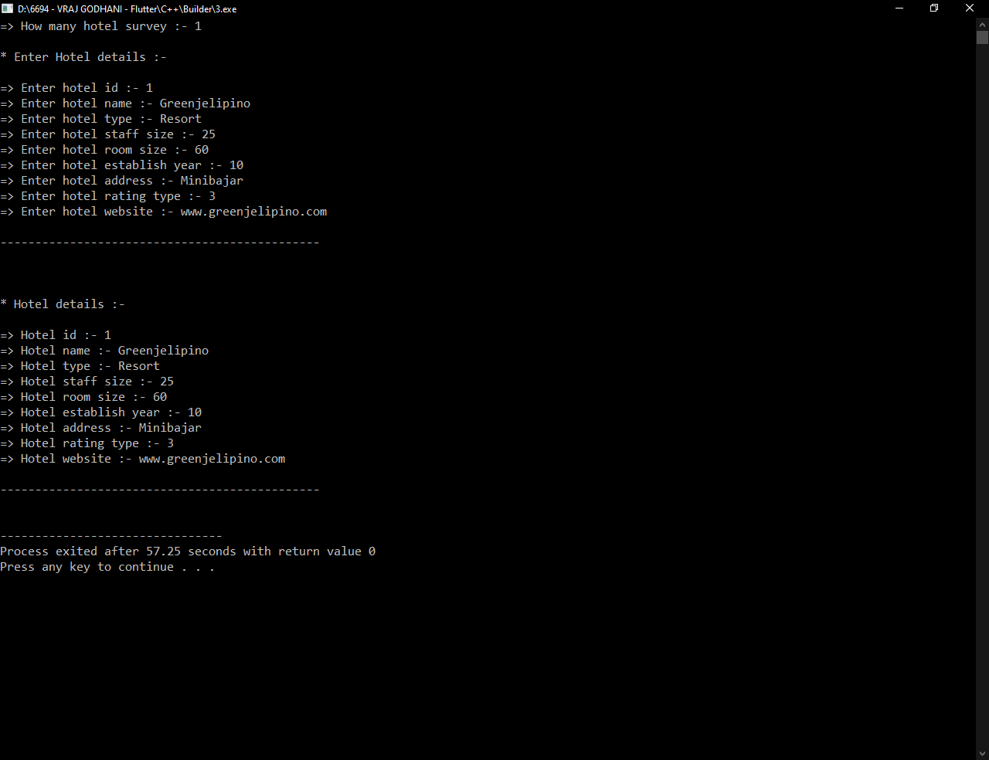

**Practical-4**

**Aim:WAP to create two class HighSchool and College with fields like id, stu_name, stu_roll_no, stu_standard, stu_age, stu_contact, stu_edu_institute_name and stu_address. Make suitable setter and getter with use of static data members.**

**Program:**

#include<iostream>

using namespace std;

class HighSchool

{

private:

int id;

char stu_name[100];

int stu_roll_no;

int stu_std;

int stu_age;

char stu_contact[100];

char stu_address[100];

static char stu_edu_school_name[100];

public:

void setData()

{

cout << "* Enter High school student details :- " << endl<<endl;

cout << "=> Enter ID : "; cin >>this-> id;

cout << "=> Enter Name : "; cin >>this-> stu_name;

cout << "=> Enter Roll no : "; cin >>this-> stu_roll_no;

cout << "=> Enter Standard : "; cin >>this-> stu_std;

cout << "=> Enter Age : "; cin >>this-> stu_age;

cout << "=> Enter Contact : "; cin >>this-> stu_contact;

cout << "=> Enter Address : "; cin >>this-> stu_address;

}

void getData()

{

cout << endl <<endl << "* High school student details :- "

<< endl<<endl;

cout << "=> ID : "<<this->id <<endl

<< "=> Name: "<<this->stu_name <<endl

<< "=> Roll no : "<<this->stu_roll_no <<endl

<< "=> Standard: "<<this->stu_std <<endl

<< "=> Age: "<<this->stu_age <<endl

<< "=> Contact: "<<this->stu_contact <<endl

<<"=> Address : "<<this->stu_address <<endl

<<"=>High school name: "<<this->stu_edu_school_name<<endl;

}

};

class College

{

private:

int id;

char stu_name[100];

int stu_roll_no;

char stu_std[100];

int stu_age;

char stu_contact[100];

char stu_address[100];

static char stu_edu_institute_name[100];

public:

void setData()

{

cout << endl <<endl << "* Enter college student details :- "

<< endl<<endl;

cout << "=> Enter ID : "; cin >>this-> id;

cout << "=> Enter Name : "; cin >>this-> stu_name;

cout << "=> Enter Roll no : "; cin >>this-> stu_roll_no;

cout << "=> Enter Standard : "; cin >>this-> stu_std;

cout << "=> Enter Age : "; cin >>this-> stu_age;

cout << "=> Enter Contact : "; cin >>this-> stu_contact;

cout << "=> Enter Address : "; cin >>this-> stu_address;

}

void getData()

{

cout << endl <<endl << "* College student details :- " << endl <<endl;

cout << "=> ID : "<<this->id <<endl

<< "=> Name: "<<this->stu_name <<endl

<< "=> Roll no : "<<this->stu_roll_no <<endl

<< "=> Standard: "<<this->stu_std <<endl

<< "=> Age: "<<this->stu_age <<endl

<< "=> Contact: "<<this->stu_contact <<endl

<< "=> Address : "<<this->stu_address <<endl

<< "=> College name : "<<this->stu_edu_institute_name <<endl;

}

};

char HighSchool :: stu_edu_school_name[100] = "Ashadeep-4";

char College :: stu_edu_institute_name[100] = "BMU";

int main()

{

HighSchool h1[100];

College c1[100];

int i,n;

cout <<"=> How many object: ";

cin >> n;

cout << endl;

for(i=0 ; i<n ; i++)

{

h1[i].setData();

c1[i].setData();

cout <<endl<<"--------------------------------------"<<endl <<endl;

}

for(i=0 ; i<n ; i++)

{

h1[i].getData();

c1[i].getData();

cout <<endl<<"--------------------------------------"<<endl <<endl;

}

return 0;

}

**Output:**

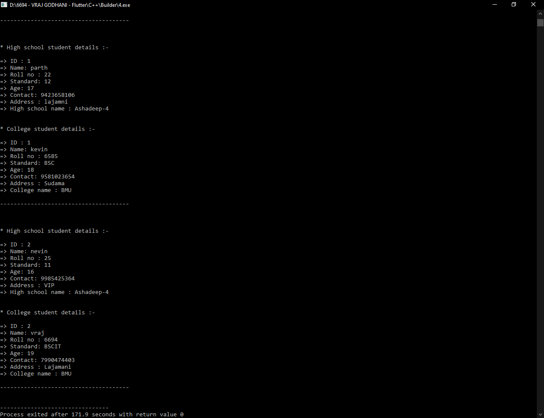

**Practical-5**

**Aim:WAP to create a class which have both static data member and static member function. That class gives details of all states in India.**

**Program:**

#include<iostream>

#include<string.h>

using namespace std;

class Stateofindia

{

private:

static char india[100][100];

public:

static void getData()

{

int i,j;

for(i=0;i<29;i++)

{

for(j=0; india[i][j]!='\0' ;j++)

{

cout << india[i][j];

}

cout << endl;

}

}

};

char Stateofindia :: india[100][100] =

{

"Andhra Pradesh",

"Arunachal Pradesh",

"Assam",

"Bihar",

"Chhattisgarh",

"Goa",

"Gujarat",

"Haryana",

"Himachal Pradesh",

"Jammu and Kashmir",

"Jharkhand",

"Karnataka",

"Kerala",

"Madhya Pradesh",

"Maharashtra",

"Manipur",

"Meghalaya",

"Mizoram",

"Nagaland",

"Odisha",

"Punjab",

"Rajasthan",

"Sikkim",

"Tamil Nadu",

"Telangana",

"Tripura",

"Uttar Pradesh",

"Uttarakhand",

"West Bengal"

};

int main()

{

Stateofindia :: getData();

return 0;

}

**Output:**

